Chapter 6

Result and Discussion

4.1 Performance Benchmarking
The main goal of this research is to identify the appropriate lightweight convolutional neural network (CNN) for real-time offline mango variety classification on Android edge devices. While predictive accuracy remains an important performance indicator, deploying deep learning models on resource-constrained smartphones requires a broader evaluation that considers computational efficiency alongside classification performance. A model that achieves marginally higher accuracy may not necessarily be the most appropriate choice if it requires significantly larger storage, longer inference time, or greater computational resources. Therefore, this research adopts a comprehensive benchmarking methodology that evaluates multiple performance aspects before selecting the final deployment model.

To achieve an objective comparison, five transfer learning-based CNN architectures—MobileNetV2, MobileNetV3-Small, EfficientNetV2B0, DenseNet121, and NASNetMobile—were trained using the identical experimental configuration described in Chapter 3. Every architecture utilized the same Mangifera2012 dataset, identical preprocessing pipeline, online data augmentation strategy, training–validation split, optimizer configuration, batch size, learning rate, and early stopping criteria. Furthermore, all models employed the same custom classification head consisting of a Global Average Pooling layer, Dropout (0.30), a Dense layer with 128 neurons, and a Softmax output layer for the ten mango varieties. Maintaining identical training conditions ensures that differences observed during evaluation originate from the architectural characteristics of the CNN models rather than inconsistencies in the experimental setup.
Unlike conventional image classification studies that rely solely on overall accuracy, this research performs a deployment-oriented benchmarking analysis by evaluating both predictive and computational performance. Four classification metrics were used to measure recognition capability:
- Classification Accuracy
- Precision
- Recall
- Weighted F1-score

Since the final objective is mobile deployment, additional engineering metrics were also considered during benchmarking:
- Model Storage Size (MB) – indicating the storage requirement of the trained model.
- Inference Latency (ms) – representing the average prediction time required for a single image.
- TensorFlow Lite Deployment Compatibility – evaluating the suitability of each architecture for Edge AI implementation.
By combining predictive performance with deployment efficiency , the benchmarking framework enables a balanced assessment of each CNN architecture

Evaluation Metrics
For multi-class classification, overall accuracy is calculated as
$$Accuracy=\frac{TP+TN}{TP+TN+FP+FN}$$
where
- TP denotes True Positives,
- TN denotes True Negatives,
- FP denotes False Positives,
- FN denotes False Negatives.
Precision evaluates the reliability of positive predictions and is defined as
$$Precision=\frac{TP}{TP+FP}$$
Recall measures the model's ability to correctly identify all samples belonging to a particular class:
$$[Recall=\frac{TP}{TP+FN]}$$
The weighted F1-score combines precision and recall into a single performance measure while accounting for class imbalance:
$$F_{1}=2 \frac{Precision×Recall}{Precision+Recall}$$
These metrics collectively provide a more reliable assessment than accuracy alone, particularly for fine-grained image classification tasks where visually similar classes may lead to different types of classification errors.
Benchmarking Results
Table 4.1 summarizes the overall benchmarking results obtained from the five evaluated CNN architectures.

Table 4.1 Comparative Performance of Evaluated CNN Architectures
Model | Accuracy (%) | Precision (%) | Recall (%) | Weighted F1 (%) | Model Size (MB) | Inference Latency (ms)
MobileNetV2 | 80.25 | 80.92 | 80.25 | 80.33 | 11.07 | 34.66
MobileNetV3-Small | 88.50 | 88.60 | 88.50 | 88.27 | 4.99 | 28.29
EfficientNetV2B0 | 92.00 | 92.08 | 92.00 | 92.00 | 24.39 | 40.26
NASNetMobile | 81.75 | 81.78 | 81.75 | 81.28 | 20.48 | 41.37
DenseNet121 | 90.259 | 90.54 | 90.25 | 90.18 | 29.82 | 68.46

Comparative Analysis

4.1.12 Comparative Analysis
The experimental results indicate that EfficientNetV2B0 achieved the best classification performance, with 92.00% accuracy and the highest weighted F1-score. Its advanced feature extraction capability enabled effective discrimination of visually similar mango varieties. However, the larger model size and longer inference time limit its suitability for real-time deployment on resource-constrained mobile devices.
Among the lightweight models, MobileNetV3-Small achieved 88.5% accuracy, only 3.5% lower than EfficientNetV2B0. Despite this small performance gap, it offered the smallest model size and fastest inference speed, making it the most practical choice for Edge AI applications where storage, memory, and response time are critical.
DenseNet121 achieved 90.25% accuracy, demonstrating strong feature representation through dense connectivity. Nevertheless, its high storage requirement and slower inference reduce its effectiveness for smartphone-based deployment.
The baseline MobileNetV2 obtained 80.25% accuracy while maintaining computational efficiency through depthwise separable convolutions. However, the absence of architectural improvements such as squeeze-and-excitation modules and Hard-Swish activation resulted in lower recognition performance than MobileNetV3-Small.
NASNetMobile produced the lowest accuracy (81.75%) among the evaluated networks. Although generated through Neural Architecture Search, it failed to surpass MobileNetV3-Small and also required greater storage and inference time, making it less suitable for efficient edge deployment.
Overall, the comparison highlights that MobileNetV3-Small provides the most balanced trade-off between classification accuracy, computational efficiency, model size, and inference latency. These characteristics make it the most appropriate architecture for offline, real-time mango variety classification on Android-based edge devices.

4.1.13 Deployment-Oriented Model Selection
Selecting an Edge AI model requires balancing classification performance with deployment efficiency rather than focusing solely on accuracy. Although EfficientNetV2B0 achieved the highest accuracy, its larger model size, higher computational cost, and slower inference limit its practicality for offline mobile applications.
In contrast, MobileNetV3-Small delivered comparable recognition performance while requiring significantly fewer computational resources. Its compact architecture, low storage requirement, fast inference, and native compatibility with TensorFlow Lite make it well suited for Android-based edge devices used in agricultural environments.
Based on the overall benchmarking results, MobileNetV3-Small was selected as the deployment model for the proposed AmmChini AI system. The model was further optimized using TensorFlow Lite Float16 post-training quantization and integrated into the Flutter application to enable efficient, real-time offline mango variety classification.

Figure 4.1 Comparative Analysis of Class-wise F1-Scores Across Lightweight CNN Architectures

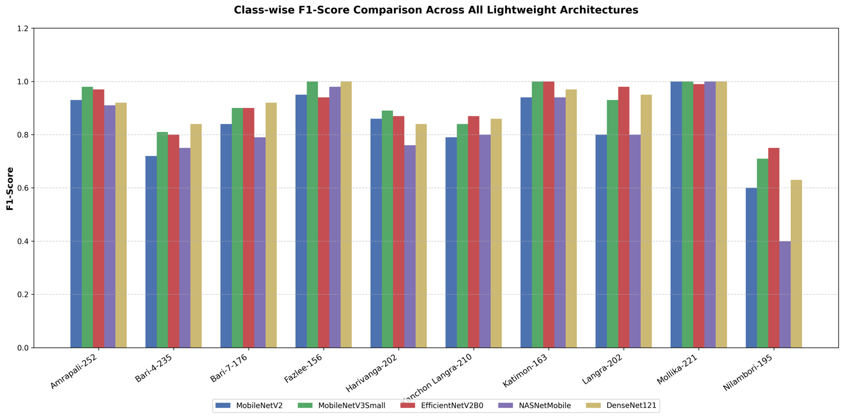

illustrates the comparative F1-score achieved by the five evaluated lightweight deep learning models: MobileNetV2, MobileNetV3-Small, EfficientNetV2-B0, NASNetMobile, and DenseNet121.

4.1.1 Analysis of MobileNetV2 Confusion Matrix
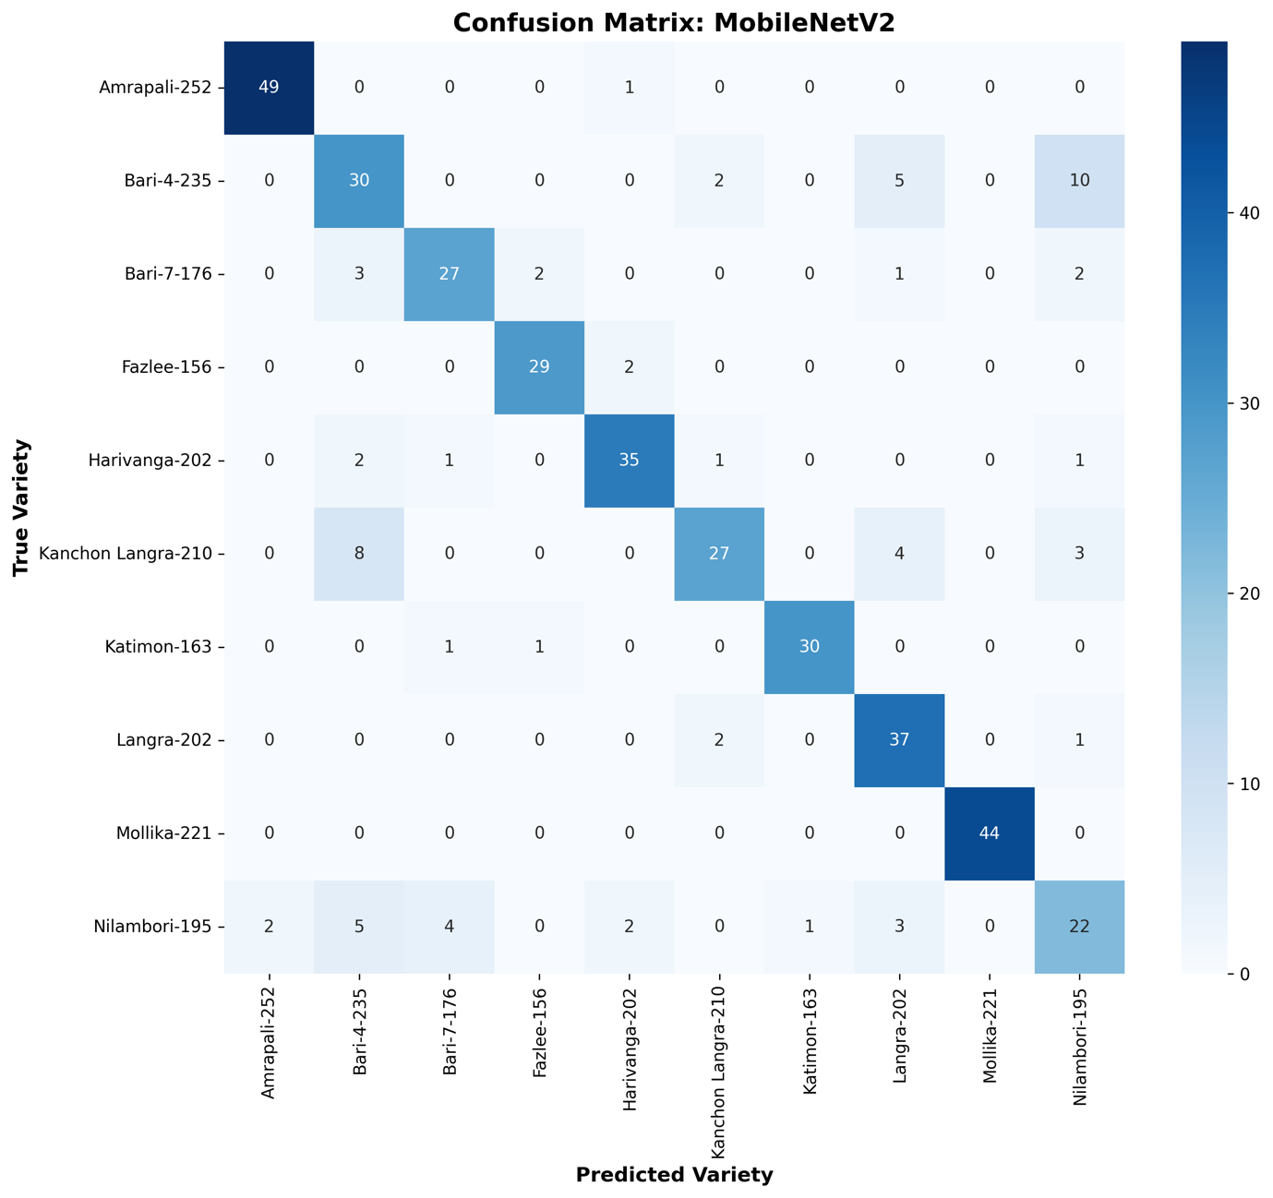

Key Observations
- Mollika-221 achieved perfect classification (44/44).
- Amrapali-252 correctly classified 49/50 samples.
- Harivanga-202, Langra-202, and Katimon-163 also demonstrated strong recognition performance.
- Bari-4-235, Kanchon Langra-210, and Nilambori-195 showed the highest misclassification rates.
- The most frequent confusion occurred between Bari-4-235 ↔ Nilambori-195 and Kanchon Langra-210 ↔ Bari-4-235.
- The results indicate that MobileNetV2 learned effective visual representations but struggled with highly similar mango varieties, explaining its lower accuracy than MobileNetV3-Small.

4.1.2 Classification Report Heatmap for MobileNetV2
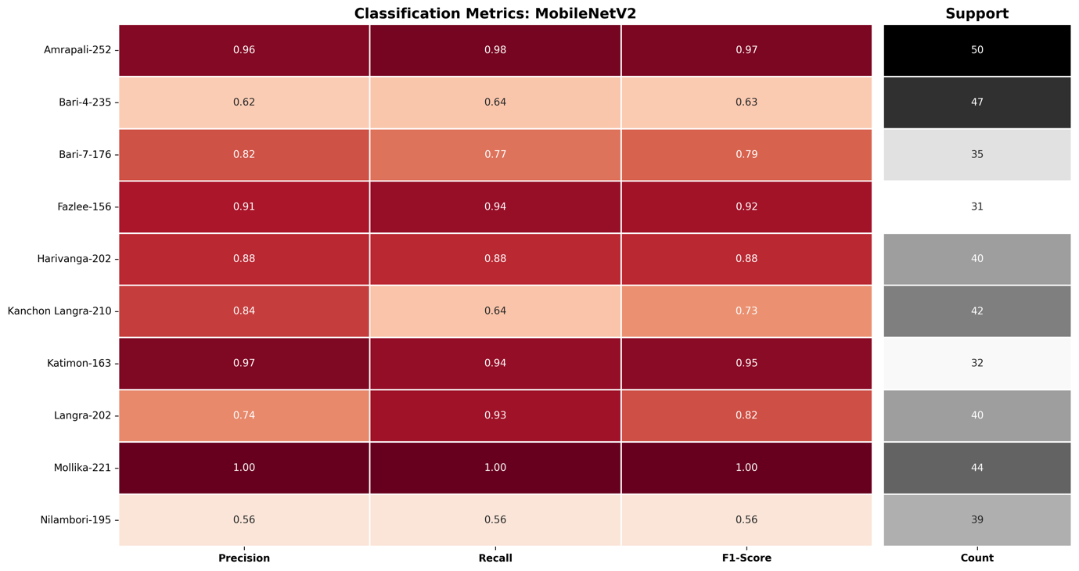

Key Observations
- Mollika-221 achieved perfect classification performance with Precision = 1.00, Recall = 1.00, and F1-score = 1.00.
- Amrapali-252, Katimon-163, and Fazlee-156 demonstrated consistently high classification metrics, indicating excellent feature separability.
- Langra-202 achieved high recall (0.93) but comparatively lower precision (0.74), suggesting occasional false positive predictions.
- Bari-4-235 and Kanchon Langra-210 exhibited moderate performance due to frequent confusion with visually similar mango varieties.
- Nilambori-195 recorded the lowest precision, recall, and F1-score (0.56), making it the most challenging class for MobileNetV2.
- The class-wise evaluation reinforces the findings from the confusion matrix and demonstrates that MobileNetV2, while computationally efficient, has limited capability in distinguishing highly similar indigenous Bangladeshi mango varieties. These limitations justify the subsequent investigation of more advanced lightweight architectures for Edge AI deployment.

4.1.3 Confusion Matrix for the MobileNetV3-Small Model
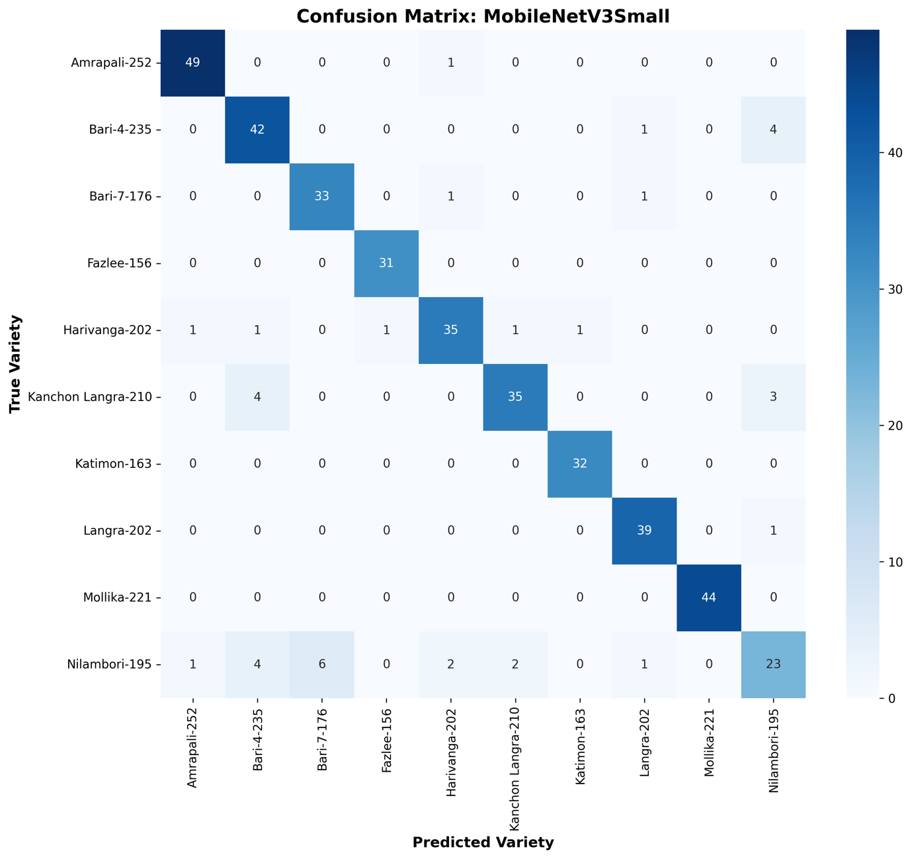

Key Observations
- Fazlee-156 (31/31), Katimon-163 (32/32), and Mollika-221 (44/44) achieved perfect classification, with no observed misclassifications.
- Amrapali-252 maintained excellent performance with 49 correct predictions out of 50.
- Langra-202 correctly classified 39 of 40 validation samples, demonstrating highly reliable recognition.
- Bari-4-235 and Kanchon Langra-210 exhibited substantial improvement compared with MobileNetV2, indicating enhanced feature discrimination.
- Nilambori-195 remained the most challenging variety; however, the number of correct predictions increased relative to the MobileNetV2 model.
- The most frequent remaining confusion occurred between Bari-4-235 and Nilambori-195, as well as Kanchon Langra-210 and Bari-4-235, reflecting their close morphological similarity.
- Overall, the confusion matrix demonstrates that MobileNetV3-Small significantly reduces inter-class confusion while maintaining computational efficiency, providing strong evidence for its selection as the final model for TensorFlow Lite optimization and deployment in the proposed AmmChini AI Edge AI system.

4.1.4 Classification Report Heatmap for the Proposed MobileNetV3-Small Model
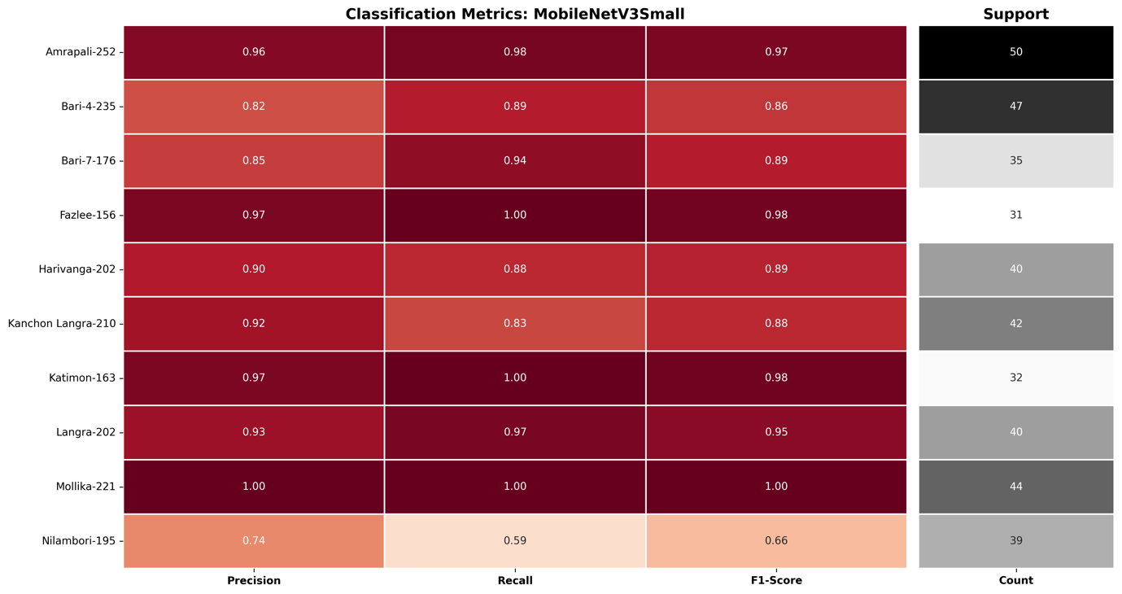

Key Observations
- Mollika-221 achieved perfect classification with Precision = 1.00, Recall = 1.00, and F1-score = 1.00.
- Fazlee-156 and Katimon-163 achieved excellent performance with F1-scores of 0.98, reflecting highly reliable recognition.
- Amrapali-252 and Langra-202 maintained outstanding classification performance, both achieving F1-scores above 0.95.
- Bari-4-235 improved significantly from an F1-score of 0.63 (MobileNetV2) to 0.86, demonstrating enhanced feature discrimination.
- Kanchon Langra-210 also exhibited a notable improvement, increasing its F1-score from 0.73 to 0.88.
- Nilambori-195 remained the most difficult class; however, its classification performance improved compared with the baseline MobileNetV2 model.
- Overall, the classification report heatmap confirms that the proposed MobileNetV3-Small architecture delivers more balanced and robust class-wise performance than the baseline MobileNetV2 while maintaining the lightweight characteristics required for efficient Edge AI deployment. These findings strongly support its selection as the final model integrated into the AmmChini AI mobile application.

4.1.5 Analysis of the EfficientNetV2-B0 Confusion Matrix
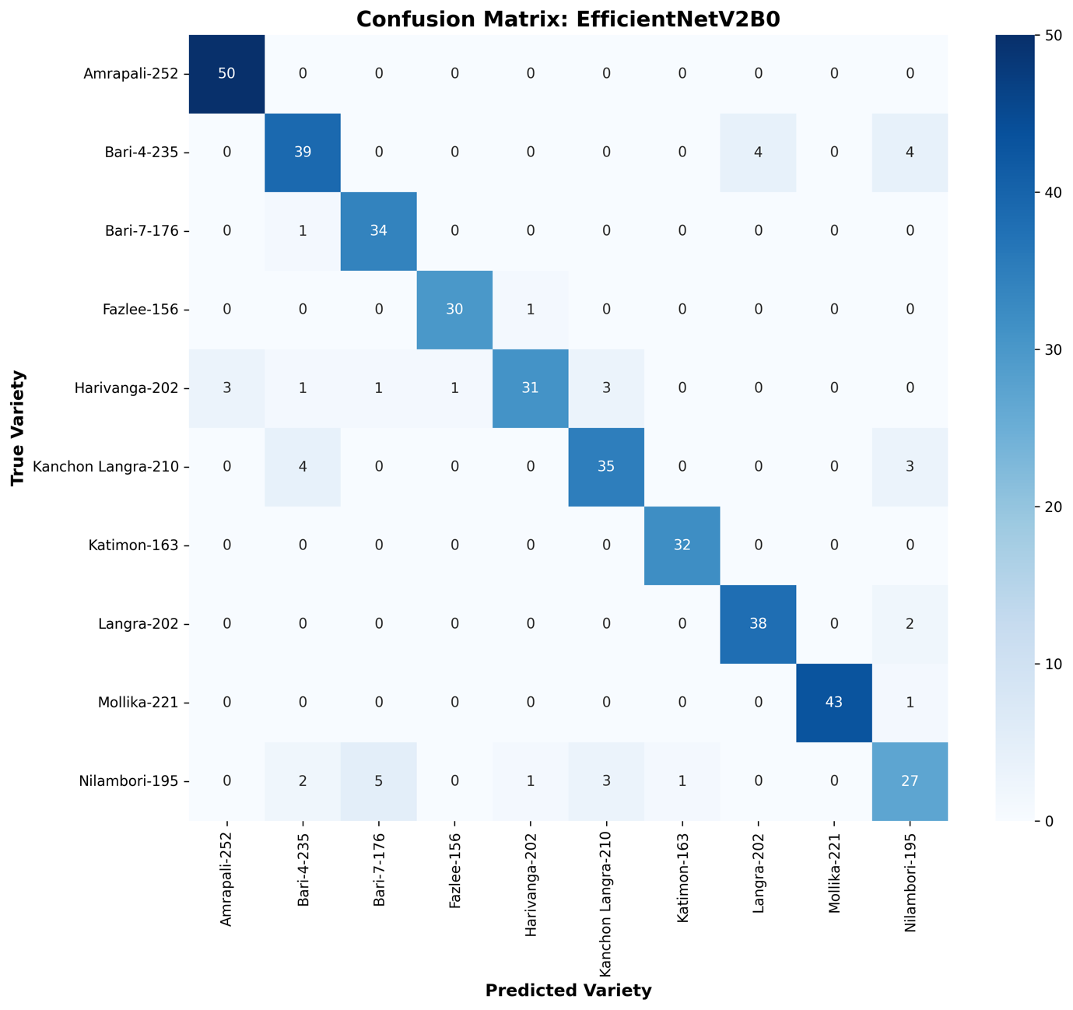

Key Observations
- Amrapali-252 and Katimon-163 achieved perfect classification, with all validation samples correctly recognized.
- Bari-7-176 achieved 34 correct predictions out of 35, demonstrating excellent recognition capability.
- Langra-202 correctly classified 38 of 40 validation images, indicating strong class separability.
- Mollika-221 achieved near-perfect performance with 43 correct predictions out of 44.
- Nilambori-195 remained the most challenging class; however, EfficientNetV2-B0 achieved the highest recognition rate for this variety among all evaluated models.
- The most frequent remaining confusion occurred between Bari-4-235, Langra-202, and Nilambori-195, reflecting their close morphological similarity.
- Although EfficientNetV2-B0 achieved the highest overall classification accuracy (92.00%), its larger model size and longer inference time reduce its practicality for resource-constrained mobile devices. These observations justify the subsequent selection of MobileNetV3-Small as the final deployment model for the proposed AmmChini AI Edge AI application.

4.1.6 Classification Report Heatmap for EfficientNetV2-B0
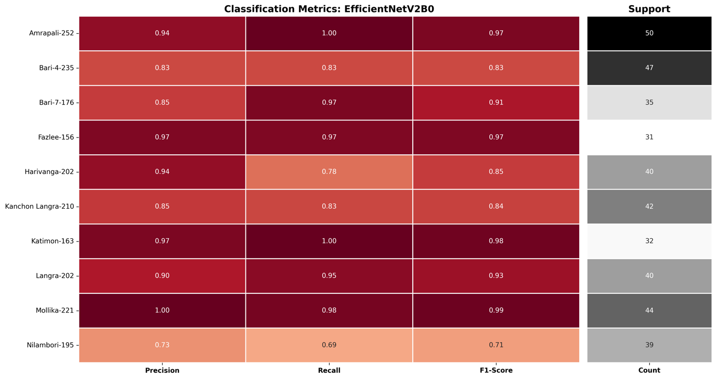

Key Observations
- Katimon-163 achieved Recall = 1.00 and an F1-score of 0.98, indicating perfect identification of all validation samples.
- Amrapali-252 achieved Recall = 1.00 with an F1-score of 0.97, demonstrating excellent recognition capability.
- Mollika-221 obtained Precision = 1.00 and an F1-score of 0.99, reflecting near-perfect classification.
- Fazlee-156 maintained balanced performance with Precision = Recall = 0.97.
- Langra-202 and Bari-7-176 both achieved F1-scores above 0.90, demonstrating strong class discrimination.
- Nilambori-195 remained the most challenging class but still achieved its highest F1-score (0.71) among all evaluated architectures.
- EfficientNetV2-B0 delivered the highest weighted Precision (0.9208), Recall (0.9200), and F1-score (0.9200) across all benchmark models, confirming its superior predictive capability.
- Despite its outstanding classification performance, the model's larger memory footprint and higher inference latency limit its suitability for real-time Edge AI deployment, reinforcing the selection of MobileNetV3-Small as the final deployment model for the AmmChini AI mobile application.

4.1.7 Analysis of the NASNetMobile Confusion Matrix
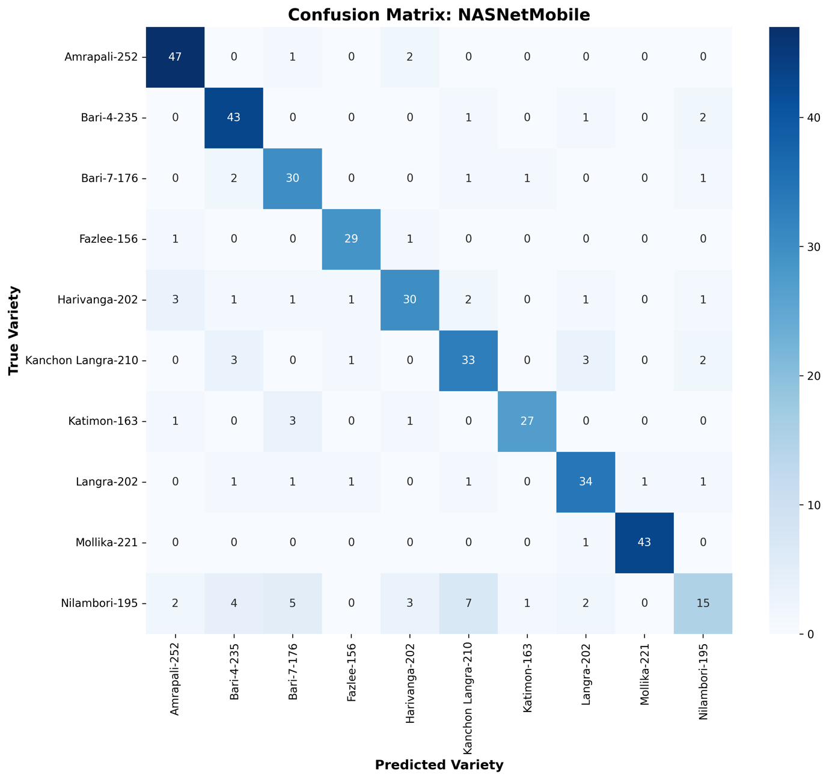

Key Observations
- Amrapali-252 achieved excellent recognition performance, with 47 of 50 validation images correctly classified.
- Bari-4-235 and Mollika-221 both correctly classified 43 validation samples, demonstrating relatively stable recognition performance.
- Langra-202 achieved 34 correct predictions out of 40, indicating moderate classification capability.
- Harivanga-202, Katimon-163, and Kanchon Langra-210 experienced noticeably higher misclassification rates than those observed in MobileNetV3-Small and EfficientNetV2-B0.
- Nilambori-195 remained the most difficult class, with only 15 correct predictions out of 39, representing the lowest class-wise recognition performance among all benchmark models.
- The most frequent confusion occurred between Nilambori-195, Bari-7-176, Harivanga-202, and Kanchon Langra-210, reflecting their close morphological similarity.
- Although NASNetMobile was designed for mobile applications, its 81.75% classification accuracy, 20.48 MB model size, and 41.37 ms inference latency provide a less favorable trade-off between accuracy and computational efficiency than the proposed MobileNetV3-Small architecture, making it less suitable for deployment in the AmmChini AI offline Edge AI application.

4.1.8 Classification Report Heatmap for NASNetMobile
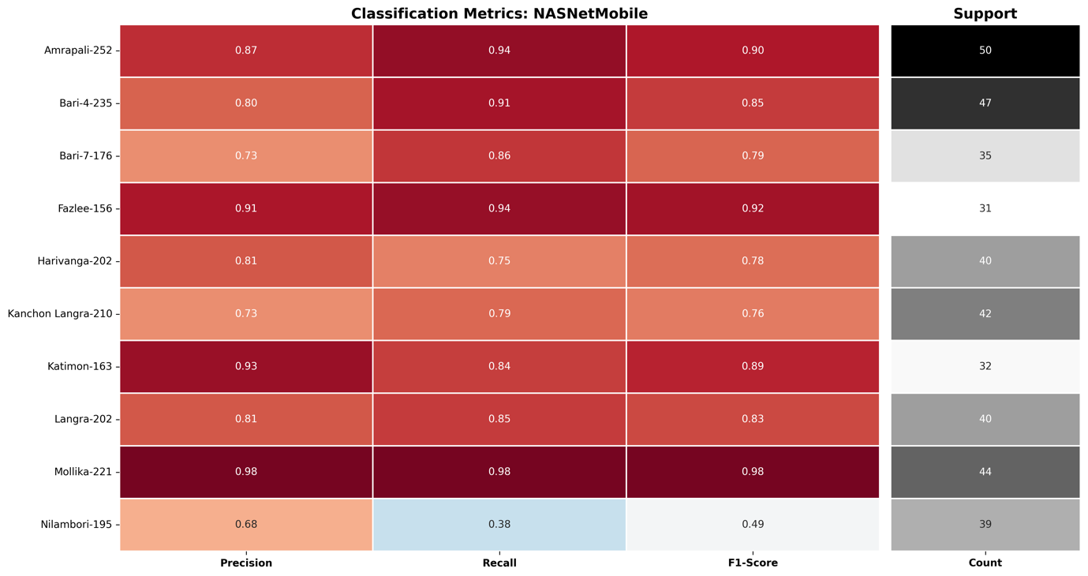

Key Observations
- Mollika-221 achieved the best overall performance with Precision = 0.98, Recall = 0.98, and F1-score = 0.98, indicating highly reliable classification.
- Fazlee-156, Amrapali-252, and Katimon-163 also demonstrated strong predictive performance, each achieving F1-scores close to or above 0.89.
- Bari-4-235 and Langra-202 exhibited balanced classification performance with F1-scores of 0.85 and 0.83, respectively.
- Harivanga-202, Kanchon Langra-210, and Bari-7-176 showed comparatively lower F1-scores, reflecting increased inter-class confusion.
- Nilambori-195 recorded the lowest performance (Precision = 0.68, Recall = 0.38, F1-score = 0.49), confirming it as the most difficult mango variety to classify.
- Compared with MobileNetV3-Small and EfficientNetV2-B0, NASNetMobile exhibited greater variation in class-wise metrics, indicating weaker feature discrimination for fine-grained indigenous mango classification.
- The classification report further supports the conclusion that NASNetMobile provides acceptable baseline performance but does not achieve the optimal balance of classification accuracy, robustness, and deployment efficiency required for the proposed AmmChini AI edge-based mobile application.

4.1.9 Analysis of the DenseNet121 Confusion Matrix
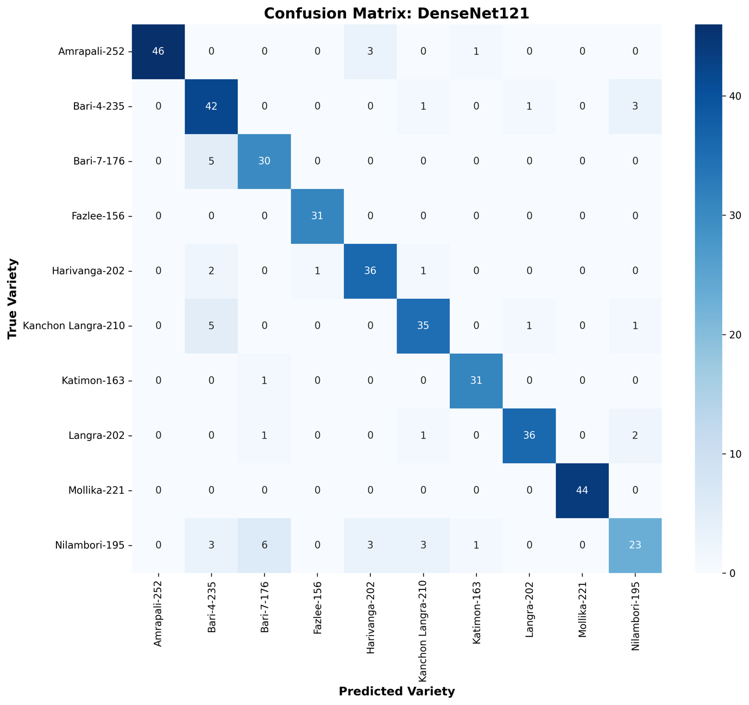

Key Observations
- Fazlee-156 and Mollika-221 achieved 100% classification accuracy, with every validation sample correctly identified.
- Harivanga-202, Langra-202, Katimon-163, and Bari-4-235 demonstrated consistently strong classification performance with only a few misclassified samples.
- Amrapali-252 achieved high recognition accuracy, with most prediction errors occurring toward Harivanga-202.
- Kanchon Langra-210 and Bari-7-176 exhibited moderate confusion, primarily with visually similar neighboring varieties.
- Nilambori-195 remained the most difficult class, with misclassifications distributed across multiple mango varieties, indicating substantial feature overlap.
- The confusion matrix confirms that DenseNet121 performs effectively for most indigenous mango varieties but still encounters challenges in distinguishing morphologically similar cultivars.
- Compared with the proposed MobileNetV3-Small model, DenseNet121 provides competitive recognition capability but exhibits greater inter-class confusion while requiring significantly higher computational resources for deployment on resource-constrained mobile devices.

4.1.10 Classification Report Heatmap for DenseNet121
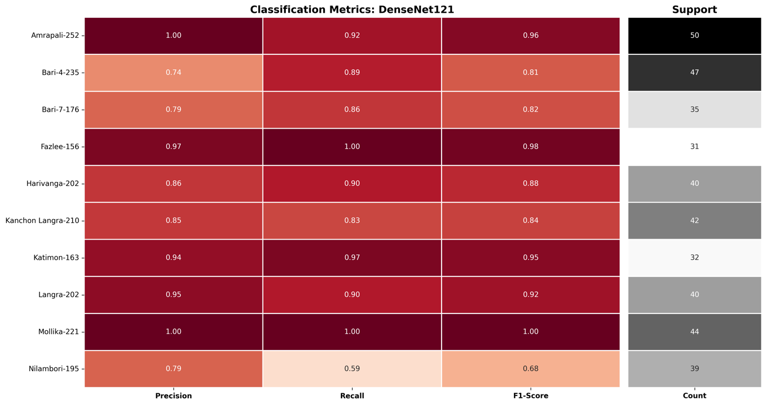
Key Observations
- Mollika-221 achieved perfect classification with Precision = 1.00, Recall = 1.00, and F1-score = 1.00, representing the best-performing class.
- Fazlee-156, Amrapali-252, Katimon-163, and Langra-202 also demonstrated excellent classification performance, each achieving F1-scores above 0.92.
- Harivanga-202 maintained balanced prediction capability with an F1-score of 0.88, indicating reliable feature discrimination.
- Kanchon Langra-210, Bari-7-176, and Bari-4-235 exhibited moderate performance due to increased confusion with visually similar varieties.
- Nilambori-195 remained the most challenging class, recording the lowest Recall (0.59) and F1-score (0.68) among all categories.
- DenseNet121 successfully learned discriminative representations for most indigenous mango varieties but exhibited reduced consistency for morphologically similar cultivars.
- Compared with the proposed MobileNetV3-Small model, DenseNet121 achieved competitive classification accuracy but offered lower deployment efficiency because of its significantly larger computational complexity, parameter count, and inference cost on mobile edge devices.

